Cuda Program for Vector Addition

#include "stdio.h" #include "math.h" #define N 10

void add ( int \*a, int \*b, int \*c )

{

int tid = 0; // this is CPU zero, so we start at zero

while (tid < N)

{

c[tid] = a[tid] + b[tid];

tid += 1; // we have one CPU, so we increment by one

}

}

int main( void )

{

int a[N], b[N], c[N];

// fill the arrays 'a' and 'b' on the CPU for (int i=0; i<N; i++)

{

a [i] = i;

b[i] = i \* i;

}

add( a, b, c );

// display the results

for (int i=0; i<N; i++)

{

}

return 0;

}

printf( "%d + %d = %d\n", a[i], b[i], c[i] );

ubuntu@ubuntu-OptiPlex-3090:~/Desktop$ nvcc ass1.cu ubuntu@ubuntu-OptiPlex-3090:~/Desktop$ ./a.out

0 + 0 = 0

1 + 1 = 2

2 + 4 = 6

3 + 9 = 12

4 + 16 = 20

5 + 25 = 30

6 + 36 = 42

7 + 49 = 56

8 + 64 = 72

9 + 81 = 90

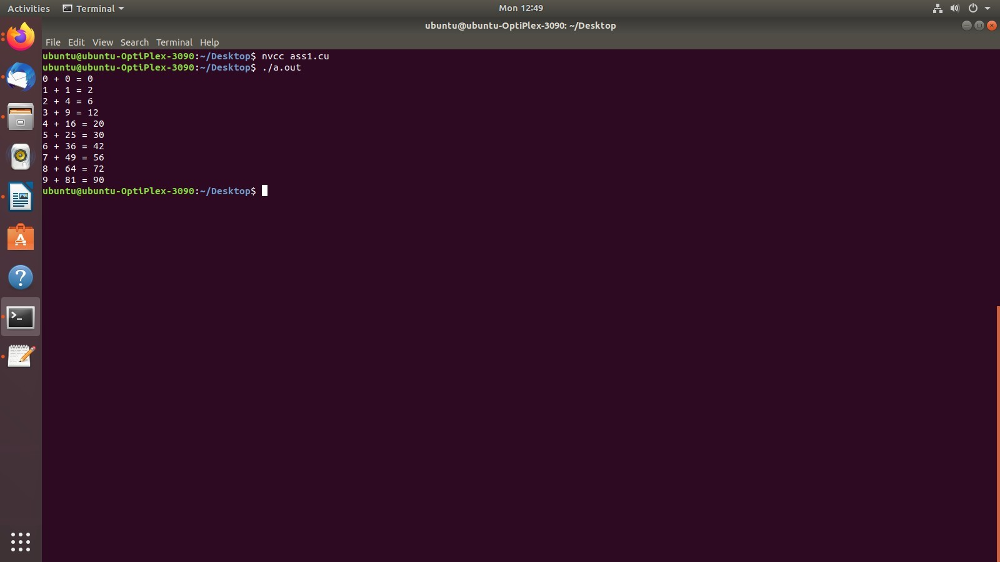

CUDA Code for matrix multiplication

#include<stdio.h> #include<cuda.h>

#define row1 2 /\* Number of rows of first matrix \*/ #define col1 3 /\* Number of columns of first matrix \*/ #define row2 3 /\* Number of rows of second matrix \*/ #define col2 2 /\* Number of columns of second matrix \*/

global void matadd(int \*l,int \*m, int \*n)

{

int x=threadIdx.x; int y=threadIdx.y;

int k;

n[col2\*y+x]=0; for(k=0;k<col1;k++)

{

n[col2\*y+x]=n[col2\*y+x]+l[col1\*y+k]\*m[col2\*k+x];

}

}

int main()

{

int a[row1][col1]; int b[row2][col2]; int c[row1][col2]; int \*d,\*e,\*f;

int i,j;

printf("\n Enter elements of first matrix of size 2\*3\n"); for(i=0;i<row1;i++)

{

for(j=0;j<col1;j++)

{

scanf("%d",&a[i][j]);

}

}

printf("\n Enter elements of second matrix of size 3\*2\n"); for(i=0;i<row2;i++)

{

for(j=0;j<col2;j++)

{

scanf("%d",&b[i][j]);

}

}

cudaMalloc((void \*\*)&d,row1\*col1\*sizeof(int)); cudaMalloc((void \*\*)&e,row2\*col2\*sizeof(int)); cudaMalloc((void \*\*)&f,row1\*col2\*sizeof(int));

cudaMemcpy(d,a,row1\*col1\*sizeof(int),cudaMemcpyHostToDevice); cudaMemcpy(e,b,row2\*col2\*sizeof(int),cudaMemcpyHostToDevice);

dim3 threadBlock(col2,row1);

/\* Here we are defining two dimensional Grid(collection of blocks) structure. Syntax is dim3 grid(no. of columns,no. of rows) \*/

matadd<<<1,threadBlock>>>(d,e,f); cudaMemcpy(c,f,row1\*col2\*sizeof(int),cudaMemcpyDeviceToHost); printf("\nProduct of two matrices:\n ");

for(i=0;i<row1;i++)

{

for(j=0;j<col2;j++)

{

printf("%d\t",c[i][j]);

}

printf("\n");

}

cudaFree(d); cudaFree(e); cudaFree(f);

return 0;

}

output:-

